Plot Worksheet

www.AliceBMcGinty.com

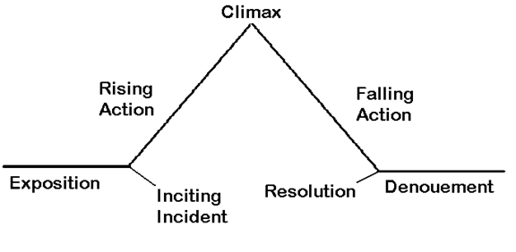

What does your character want or what is their problem? Is there a LOT at stake?

What is the inciting incident (the event that gets the story started)?

What is the rising action, or tensions, in the story?



What will your character do to solve the problem or get what they want?

What is the resolution of the story?

What is my character’s internal journey? (How does the character grow emotionally? Is there a moral dilemma?)

Creating Scenes – A Worksheet

www.AliceBMcGinty.com

Scenes are the building blocks of stories.

* Scenes use action and dialog to move the story forward.
* Scenes take place in a particular place at a particular time
* Scenes have tension or conflict
* Something changes by the end of the scene

What makes the writing in a scene come to life?

* Sensory detail: What does your character…

 see C:\Users\Alice\AppData\Local\Microsoft\Windows\Temporary Internet Files\Content.IE5\H7HM5O07\MC900238192[1].wmfhear C:\Users\Alice\AppData\Local\Microsoft\Windows\Temporary Internet Files\Content.IE5\ULG0UNF0\MC900211478[1].wmfsmell C:\Users\Alice\AppData\Local\Microsoft\Windows\Temporary Internet Files\Content.IE5\H7HM5O07\MC900290188[1].wmftaste Feel

C:\Users\Alice\AppData\Local\Microsoft\Windows\Temporary Internet Files\Content.IE5\H7HM5O07\MC900149862[1].wmf Temperature?  Is your character in motion? What does it feel like?

* Dialogue: What does the character say? Make dialogue realistic. Pay attention to how people talk.
* Action: Show the action. Use active verbs.

Instead of “The boy was scared,” you can write “The boy’s heart thumped.”

Put it all together – Sensory detail, dialogue, and action. Instead of “The girl was lost” you might write:

As she ran, Meg’s boots clicked on the cobblestone street, matching the beating of her heart. “Where am I?” she cried out loud.

Now you try it: